Double and triple plays

According to the Definition of Terms of the OBR, a double or triple play is "a play by the defense in which two or three offensive players are put out as a result of continuous action, providing there is no error between putouts."
"The official scorer shall credit participation in a double play or triple play to each fielder who earns a putout or an assist when two or three players are put out between the time a pitch is delivered and the time the ball next becomes dead or is next in possession of the pitcher in a pitching position, unless an error or misplay intervenes between putouts" [OBR 9.11].
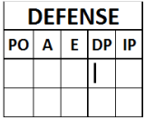 | Consequently, on the score-sheet ("DP" column on the defense side) a participation in a double play or triple play should be credited to every fielder who took part in the play
IMPORTANT: It should also be borne in mind that an error or misplay (even if not recorded as an error) breaks the double or triple play.
The symbol used is a single circle around the putouts and a line joining the two or three circles.
"The official scorer shall credit a double play or triple play also if an appeal play after the ball is in possession of the pitcher results in an additional putout" [OBR 9.11, Comment].
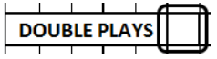 | The total number of double and/or triple plays earned by each team should be recorded in the square above the pitchers’ defending statistics, to the right of the words "DOUBLE PLAYS". The totals line under the "DP" column should contain the total number of times each individual fielder participated in a double or triple play.

- Reverse force double play [OBR Definition of Terms]. "Is one in which the first out is a force play and the second out is made on a runner for whom the force is removed by reason of the first out. Example of reverse force play: runner on first, one out; batter grounds to first baseman, who steps on first base (one out) and throws to second baseman or shortstop for the second out (a tag play) ". After the hindmost runner is put out, the leading runner or runners are no longer forced to advance and have to be tagged out. The same symbols are used to indicate this type of double or triple play as for the others.
- Grounded into double play - This is charged against a batter when the situation on the field meets the following criteria:
1. Less than two out.
2. One or more runners forced to advance (or reverse-forced).
3. Ground ball to the infield that results in two or three putouts or that would have done so if it had not been for decisive errors.
If the double or triple play is a result of ‘interference of a preceding runner’ the official scorer will not charge a grounded into double play to the batter’ [OBR 9.02 (a) (17) Comment]
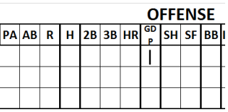 | The symbol for grounded into double play is "GDP" written inside the circle that indicates the putout of the same batter, or, in the event that he reached first base, the box for first base. Each time that the initials "GDP" appear on the score report we must charge a “grounded into double play” against the batter in question by recording it in the appropriate column on the offensive team’s sheet.

Example 1: With first base occupied, the batter hits a line ball which is caught by the second baseman.
The runner, who had broken away from first base, tries to retouch but is anticipated by an assist from the second baseman.
This is a double play but does not count as a GDP against the batter, as it
was not a ground ball.
WBSC |  | Traduction dans l’outil de scorage |  | Outil
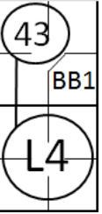 |  | /* Premier batteur avance sur un BB */  action { batter ->BB }  /*  Deuxième batteur retiré sur une line drive par le  défenseur de la deuxième base. Double jeu, le défenseur  de la deuxième base renvoie à temps vers le défenseur de  la première base pour faire le retrait */  action { batter ->L4, runner1 ->43 } |  | 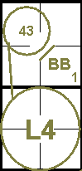

Example 2: With a runner on second base, the batter hits a ground ball to the shortstop, who catches it and tags out the runner attempting to reach third base from second, then throws the ball to first base in time to put out the batterrunner.
This is not a GDP, since the runner on second base was not forced to advance.
WBSC |  | Traduction dans l’outil de scorage |  | Outil
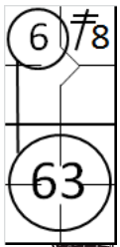 |  | /* Premier batteur avance sur un double dans le champ centre */  action { batter ->2B8 }  /* Deuxième batteur retiré sur une sur une frappe au sol vers l'arrêt court. Double jeu, le défenseur arrêt court renvoie à temps vers le défenseur de la première base pour faire le retrait */  action { batter ->6, runner2 ->63 } |  | 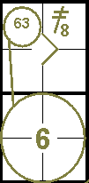

Example 3: First base is occupied and the batter has two strikes against him. On the next pitch, the runner tries to steal second base. The pitch is a third strike, which means the batter is struck out.
The catcher then succeeds in throwing to second base in time to put out the runner.
Clearly, this is not a hit into a double play, although it is a double play, since there was no break between the two outs; in other words, the two outs were made during the course of the same action, without any errors.
WBSC |  | Traduction dans l’outil de scorage |  | Outil
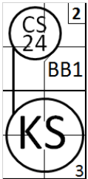 |  | /* Premier batteur avance sur un 'base on ball' */  action { batter ->BB }  /* Deuxième batteur strikeout swingé.  C’est un double jeu, le receveur renvoie à temps la balle vers le défenseur de la deuxième pour retirer le coureur qui volait la deuxième base */  action{ batter ->KS, runner1 ->CS24 } |  | 

Example 4: With first and second bases occupied, the third batter hits a ground ball to the shortstop, who throws the ball to first base in time to put out the batter-runner.
Both runners advance, and the lead runner continues to run for home plate.
The first baseman throws to home in time to put out the runner.
The defense is awarded a double play but not a grounded into double play, because the runner is not forced to advance. A participation should be credited to every fielder who took part in the play.

WBSC |  | Traduction dans l’outil de scorage |  | Outil
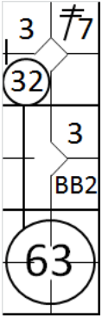 |  | /* Premier batteur avance sur un double hit vers le champ gauche */  action { batter ->2B7 }  /* Deuxième batteur avance sur un 'Base on Ball' */  action { batter ->BB }  /* le Batteur frappe une balle au sol vers l'arrêt court qui relaye à temps en première base pour faire le retrait */  /* Les deux coureurs en profite pour avancer d'une base */  /* le coureur qui arrive ne troisième base tente de gagner le point, mais se fait retirer par le receveur assisté par le */  /* défenseur de la première base */  action { batter ->63, runner1 ->+, runner2 ->+32 } |  | 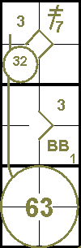

Example 5.a: With first and second bases occupied, the batter hits a ground ball to the third baseman who puts out the runner who is forced to third base, and completes the double play by assisting the second baseman.
A GDP is charged against the batter-runner, even though he was not put out himself.

WBSC |  | Traduction dans l’outil de scorage |  | Outil
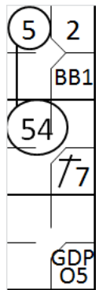 |  | /* Premier batteur avance sur 'Base on Ball' */  action { batter ->BB }  /* Deuxième batteur avance sur un hit en champs gauche, le coureur en première base avance */  action { batter ->1B7, runner1 ->+ }  /* Batteur frappe un balle au sol vers le défenseur de la troisième base qui touche sa base */  /* puis relais a temps vers le défenseur de la deuxième base pour retirer le coureur arrivant de la première base */  action{ batter ->GDPO5, runner1 ->54, runner2 ->5 } |  | 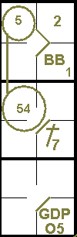

Example 5.b: With first and second bases occupied, the batter hits a ground ball to shortstop who assists the second baseman to put out the runner who is forced to second base, and completes the double play by assisting the third baseman for the putout on the lead runner. This is a reverse double play.
Also in this case a GDP is charged against the batter-runner, eventhough he was not put out himself.

WBSC |  | Traduction dans l’outil de scorage |  | Outil
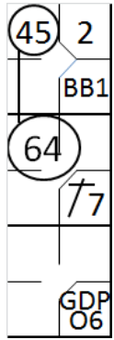 |  | /* Premier batteur avance sur 'Base on Ball' */  action { batter ->BB }  /* Deuxième batteur avance sur un hit en champs gauche, le coureur en première base avance */  action { batter ->1B7, runner1 ->+ }  /* Batteur frappe une balle au sol vers le défenseur arrêt court qui renvoie à temps la balle au défenseur */  /* de la deuxième base pour retirer le coureur venant de la première base */  /* Ce défenseur relais la balle au défenseur de la troisième base qui touche le coureur arrivant de la deuxième base */  action{ batter ->GDPO6, runner1 ->64, runner2 ->45 } |  | 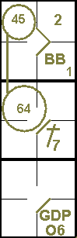

Example 6: With a runner on first base, the batter hits a ground ball which is caught by the shortstop, who throws to second in time to put out the runner.
In turn, the second baseman throws to first and puts out the batter-runner.
The official scorer awards a double play to the team, participation in a double play to the three fielders who took part in the action (shortstop, second baseman, first baseman) and a grounded into double play to the batter.
WBSC |  | Traduction dans l’outil de scorage |  | Outil
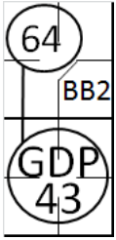 |  | /* Premier batteur avance sur 'Base on Ball' */  action { batter ->BB }  /* Le deuxième batteur frappe une balle roulante sur l'arrêt court qui récupère la balle */  /* à temps au défenseur de la deuxième base pour retirer le coureur venant de la première base */  /* Le défenseur de la deuxième base revoie a temps la balle au défenseur de la première base pour retirer le coureur batteur */  action { batter ->GDP43, runner1 ->64 } |  | 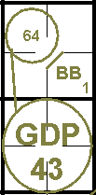

Since the column "DP" is used for recording both double and triple plays, when a triple play occurs the NOTES on the score card should state "The DP column for the … team also includes one triple play". Batterrunners may also be given a "GDP" for a triple play, and the symbol remains the same.
Example 7: Bases are full. The batter hits a line drive which is caught by the third baseman.
The third baseman, after catching it, tags third base andretires the runner who had left third base, then throws to second in time to put out the runner who had left second.
This is not a grounded into double play because it was not aground ball.

WBSC |  | Traduction dans l’outil de scorage |  | Outil
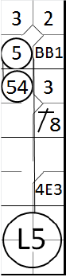 |  | /* Premier batteur avance sur 'Base on Ball' */  action { batter ->BB }  /* Le deuxième batteur avance sur un hit en champs centre' */  action { batter ->1B8, runner1 ->+ }  /* Le troisième batteur avance sur une erreur du défenseur de la première base après un relais du fégenseur de la troisème base*/  action{ batter ->4E3, runner1 ->+ , runner2 ->+ }  /* Le quatrième batteur est retiré par le défenseur de la troisième base sur une line drive*/  /* le défenseur touche sa base et retire le coureur en troisième avant qu'il ne revienne sur sa base */  /* puis relaie à temps la balle vers le défenseur de la deuxième base pour retirer le coureur en deuxième avant qu'il ne touche sa base */  action{ batter ->L5, runner1 ->+, runner2 ->54 , runner3 ->5} |  | 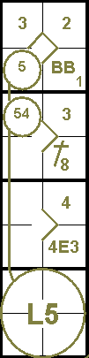

Example 8: Bases are loaded. The batter hits a ground ballwhich is fielded by the third baseman. He tags the base, thenthrows the ball to the second baseman who catches it, touchesthe base and throws it to first base for the third out.
A "GDP" is charged against the batter-runner.

WBSC |  | Traduction dans l’outil de scorage |  | Outil
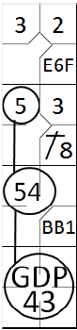 |  | /* Le Premier batteur avance sur une erreur de rattrapée de fly dû à l'arrêt court */  action { batter ->E6F }  /* Le deuxième batteur avance sur un hit en champs centre, le coureur en une avance */  action { batter ->1B8, runner1 ->+ }  /* Le troisième batteur avance sur 'Base on Ball', tous les coureurs avance */  action{ batter ->BB, runner1 ->+, runner2 ->+ }  /* Le quatrième batteur frappe une balle au sol vers le défenseur de la troisième Base qui touche sa base et retire le coureur venant de la deuxième base, il relai a temps vers le défenseur de la deuxième base. Pour retirer le coureur venant de la première base. Le défenseur de la deuxième relaie aussi a temps vers le défenseur de la première base pour retirer le batteur coureur */  action{ batter ->GDP43, runner1 ->54, runner2 ->5 } |  | 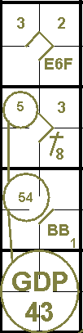

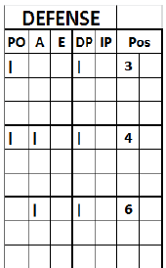 | In the case of Example 6, the double play is noted in the defense score report as shown opposite:  - With a vertical stroke in the “PO” column next to the fielders who made the outs;  - With a vertical stroke in the “A” column next to any fielders who assisted;  - With a single vertical stroke in the “DP” column next to the fielders who participated in the double play, regardless of whether they made an out, an assist or both.

In practice, an assist should be credited to the shortstop, an assist and aputout to the second baseman and a putout to the first baseman.Moreover, one participation in a double play should be credited to allthree fielders.
A double or triple play is also credited to the team, the total number ofsuch at the end of the game should be reported at that time in the squareabove the pitchers’ defense statistics, to the right of the words “DOUBLEPLAYS”.

